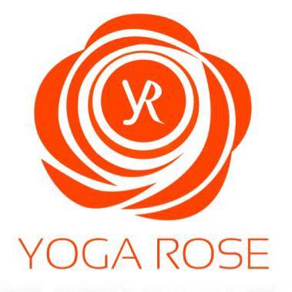

Liability Waiver

In signing below I agree that Yoga Rose is in no way responsible for the safekeeping of my personal belongings while I attend class.

I understand that classes at Yoga Rose may be physically strenuous and I voluntarily participate in them with full knowledge that there is risk of personal injury, property loss or death.

I agree that neither I, my heirs, assigns or legal representatives will sue or make any other claims of any kind whatsoever against Yoga Rose or its members for any personal injury, property damage/loss, or wrongful death, whether caused by negligence or otherwise.

Signed: _______________________________________ Date:____________

PRIVACY STATEMENT

To keep up to date on the latest classes, workshops and yoga retreats, health and wellbeing tips, etc please leave your email address below.

We promise to always keep your details safe and if you change your mind about hearing from us, you can stop receiving our updates at any time by unsubscribing, or emailing us directly on rose@yogarose.co.uk

Email Address: __________________________________

